Build and Publish to IIS

In order to deploy the .NET application to IIS , please ensure to build and package the application before moving it to IIS on Windows EC2 servers .

The below steps were followed to build then package the application.

Build

1 . Install the appropriate version of Visual Studio (preferably 2013 in this case) , open the solution file(Opserver.sln) located in ....\Opserver folder.

2. Then right click the Opsserver project and select Build. Ignore any warnings but do note to see if any errors occur.

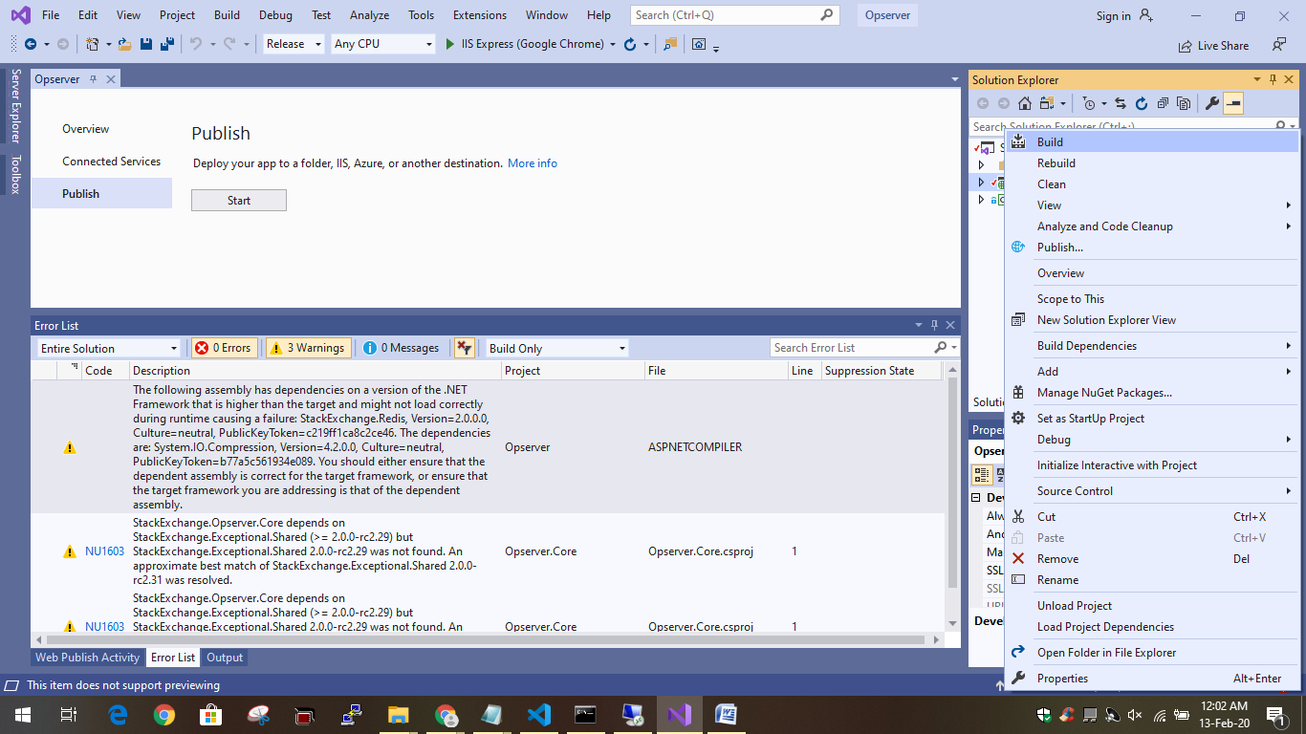

3. Once the build is done , you should be able to see the below message.

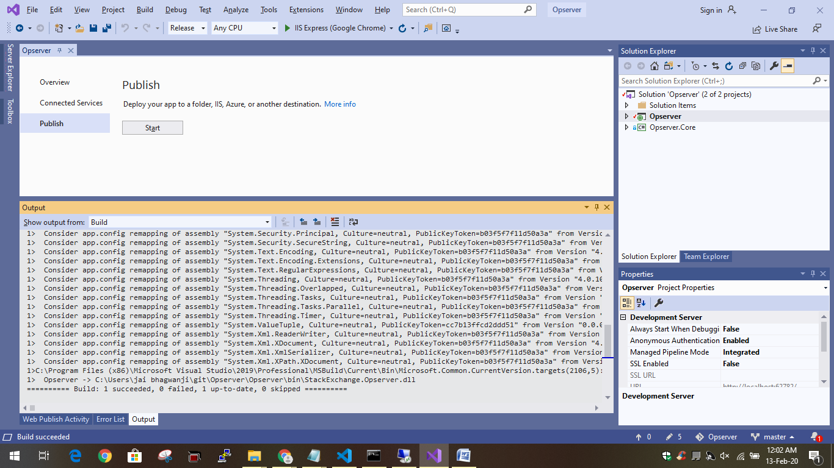

Now , publish is done as shown below :

Publish

1. Right click on the Opserver project and select publish.

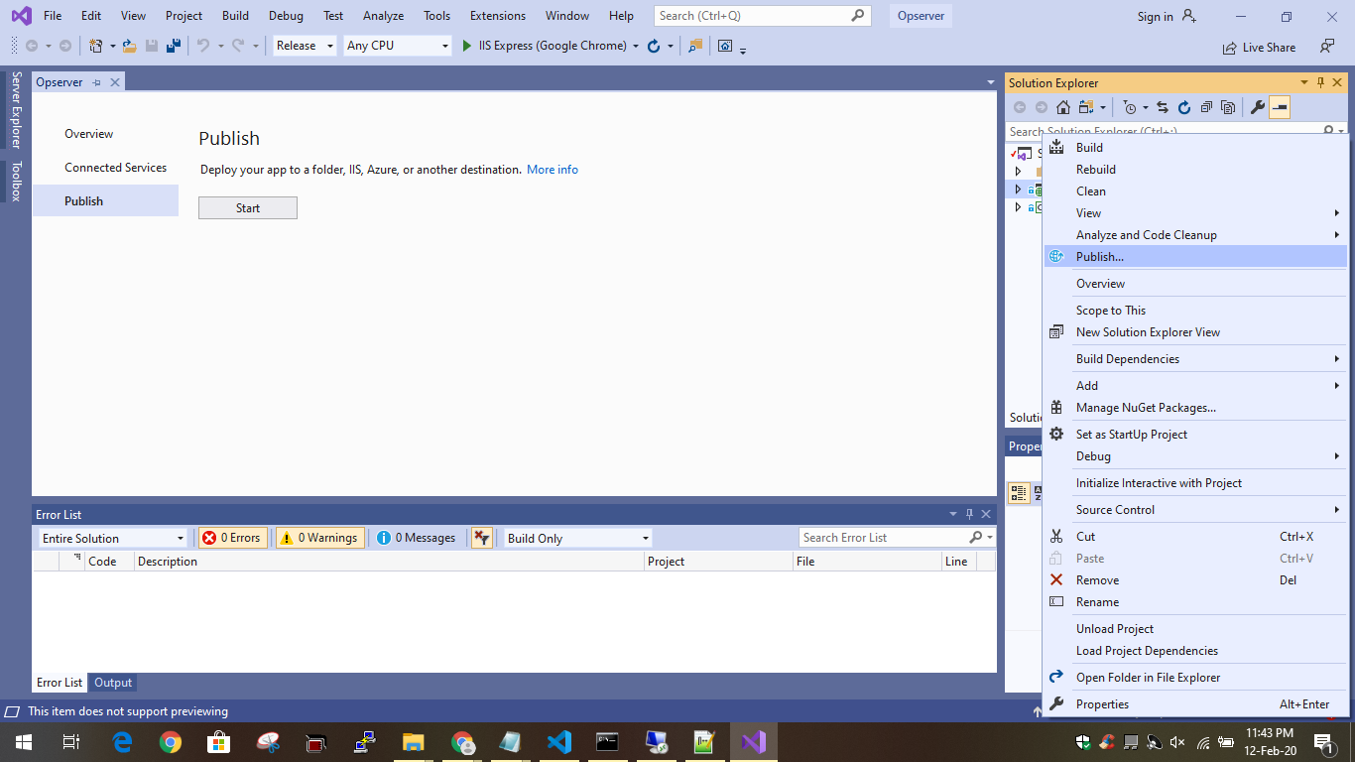

1. Now , select start as shown below and follow the options :

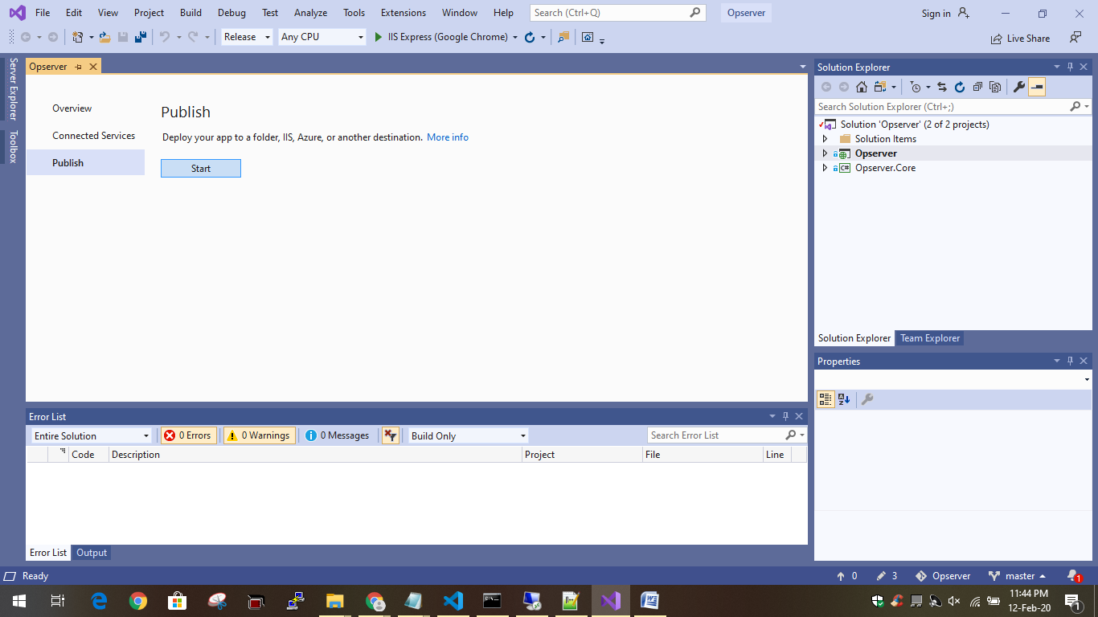

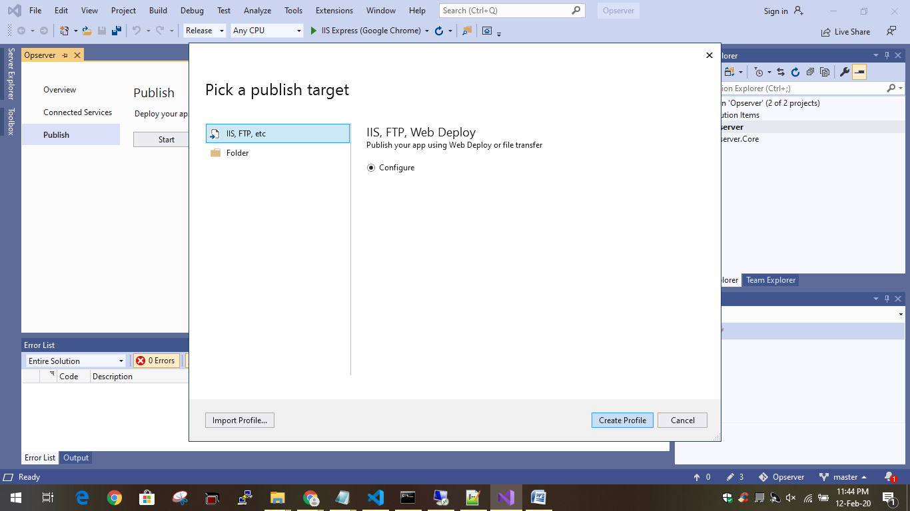

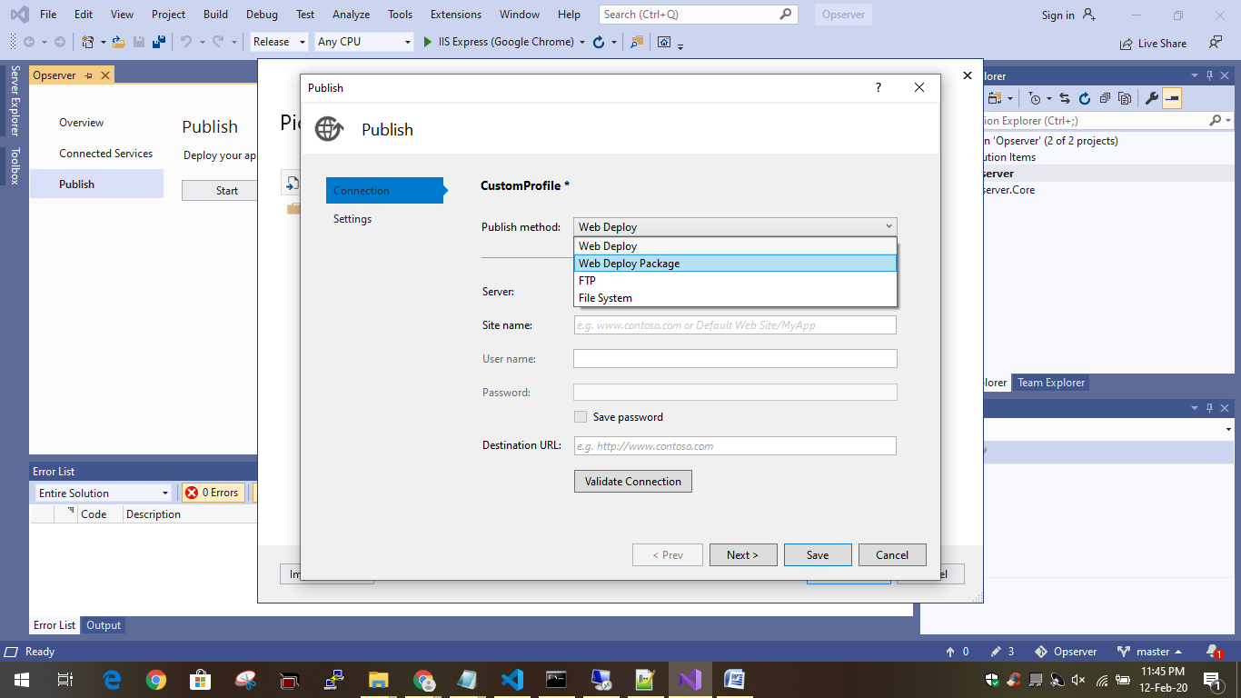

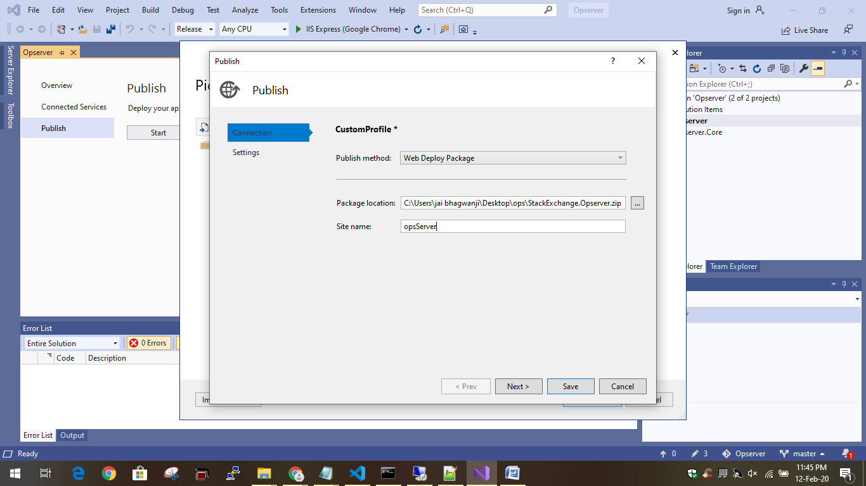

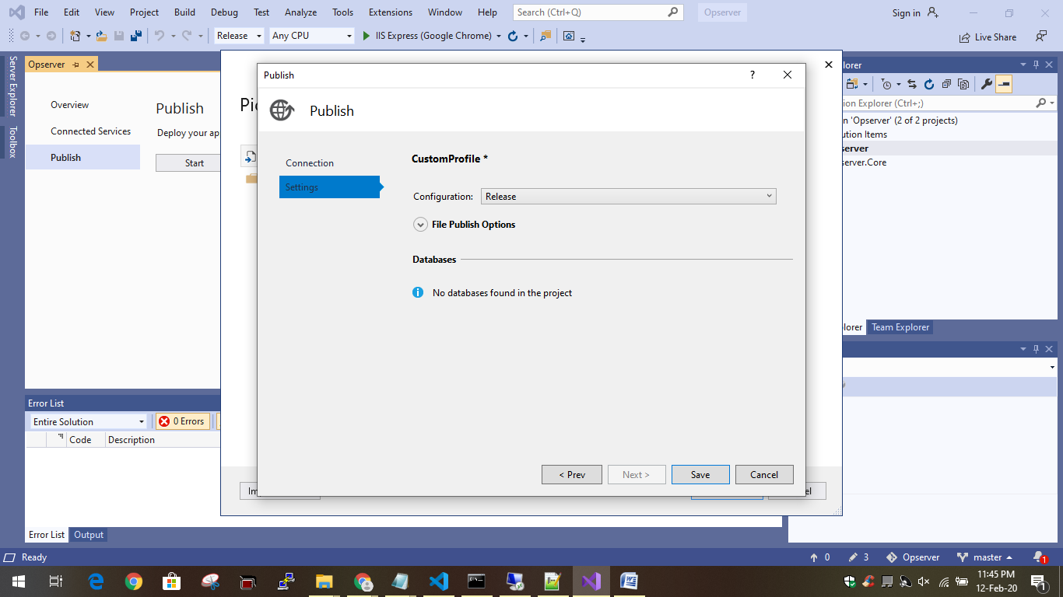

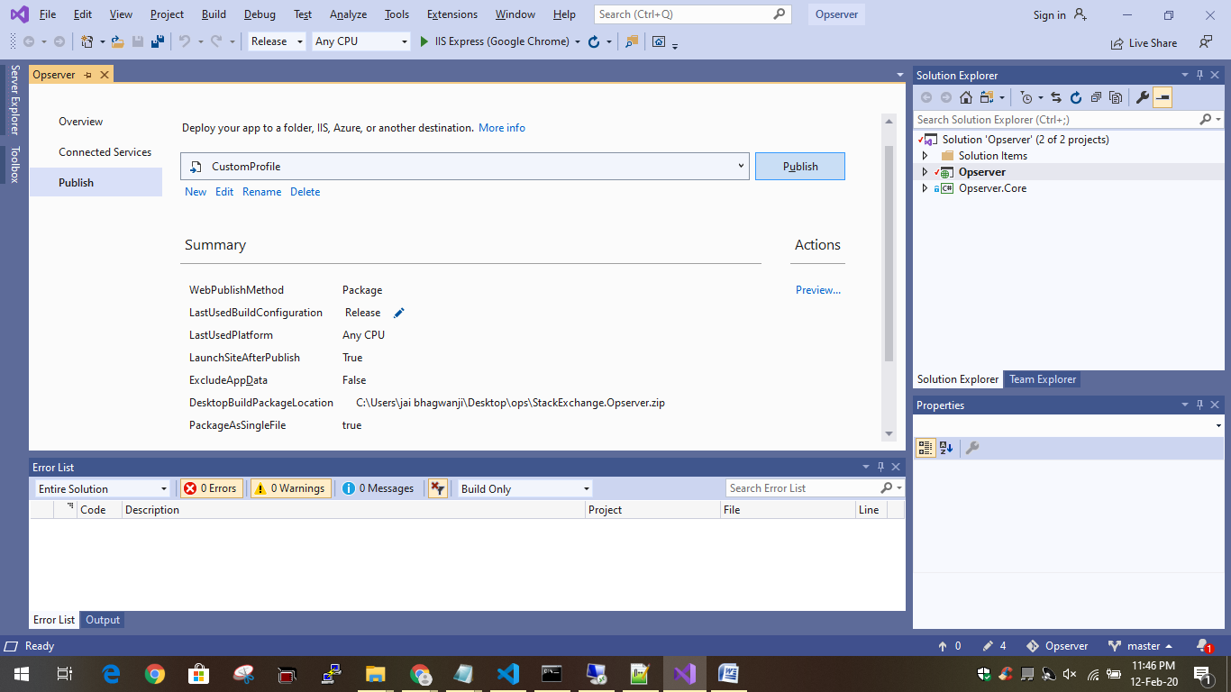

1. Once clicked on publish , please wait for the publish to complete , this will generate a zip file that you can now deloy onto IIS server.

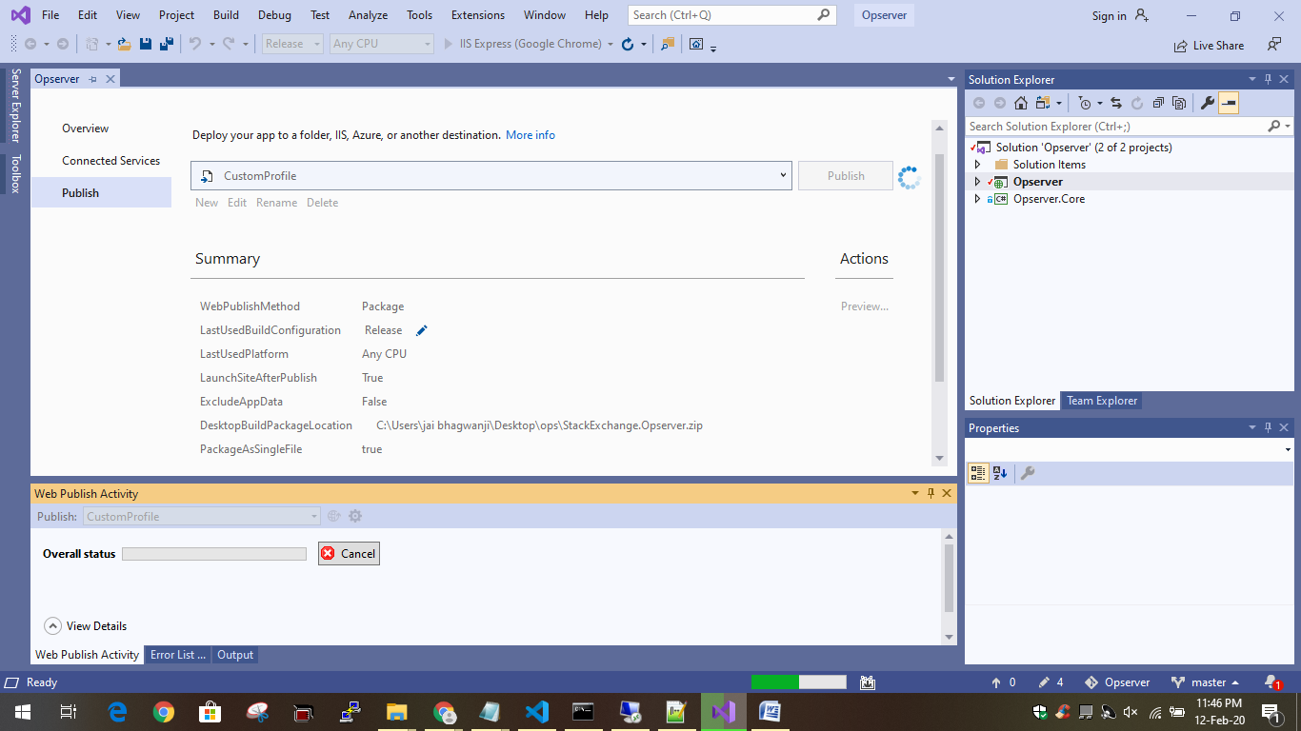

1. The package is now ready to be deployed to IIS.